**Networking**

1. **Setup GNS3 environment and create two gateway topology**.

**Installing GNS 3 on Ubuntu 16.04**

**first of all you need root previlages, so for root privilage you should use**

**command:**

* + sudo apt-get-update
  + sudo apt-get-upgrade
  + sudo apt install root-system-bin

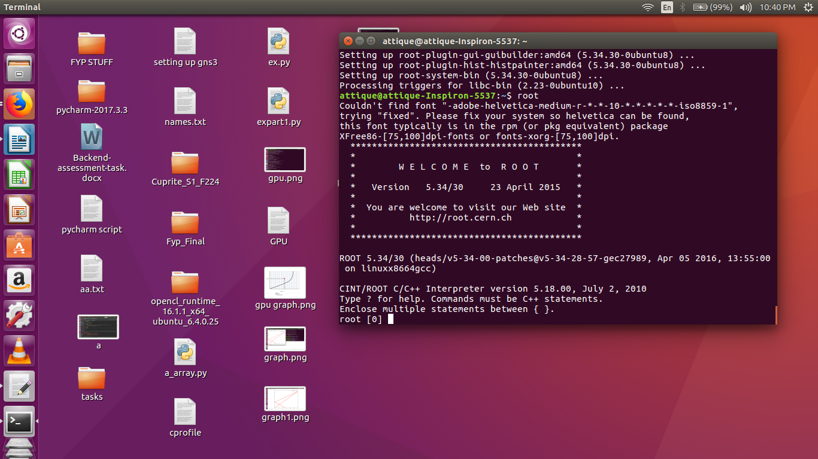

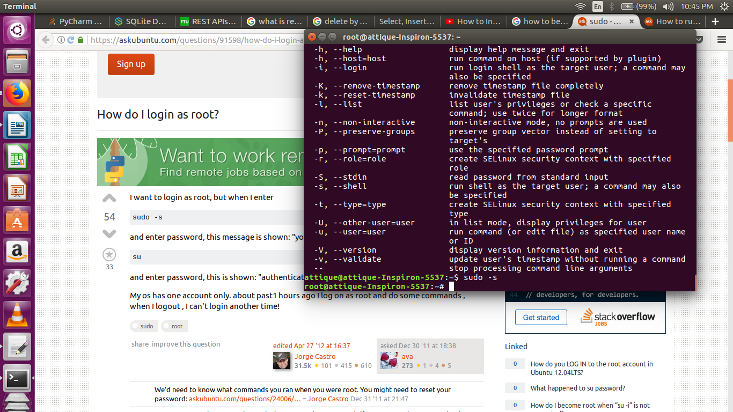

**To install Gns3 :**

* sudo add-apt-repository ppa:gns3/ppa

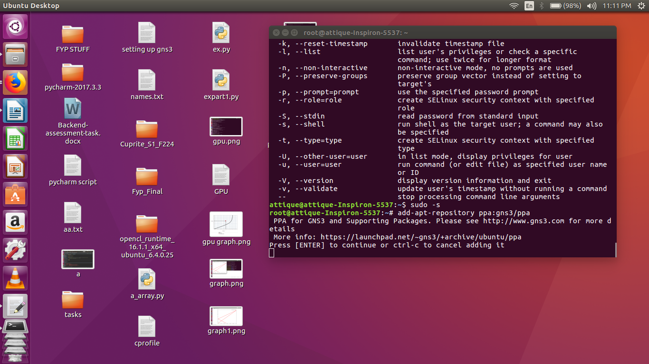

**then update:**

* 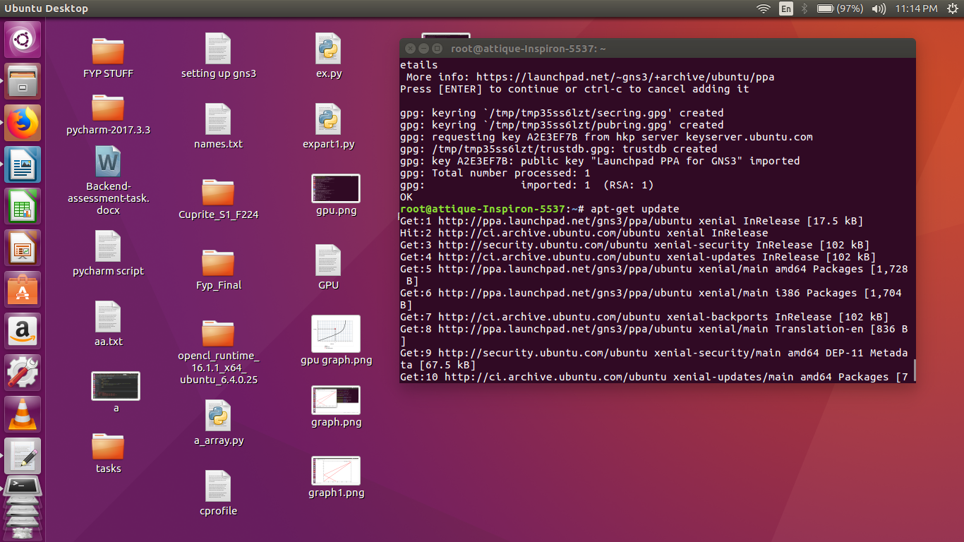apt-get update

**Installing dependencies:**

* apt-get install dynamips gns3

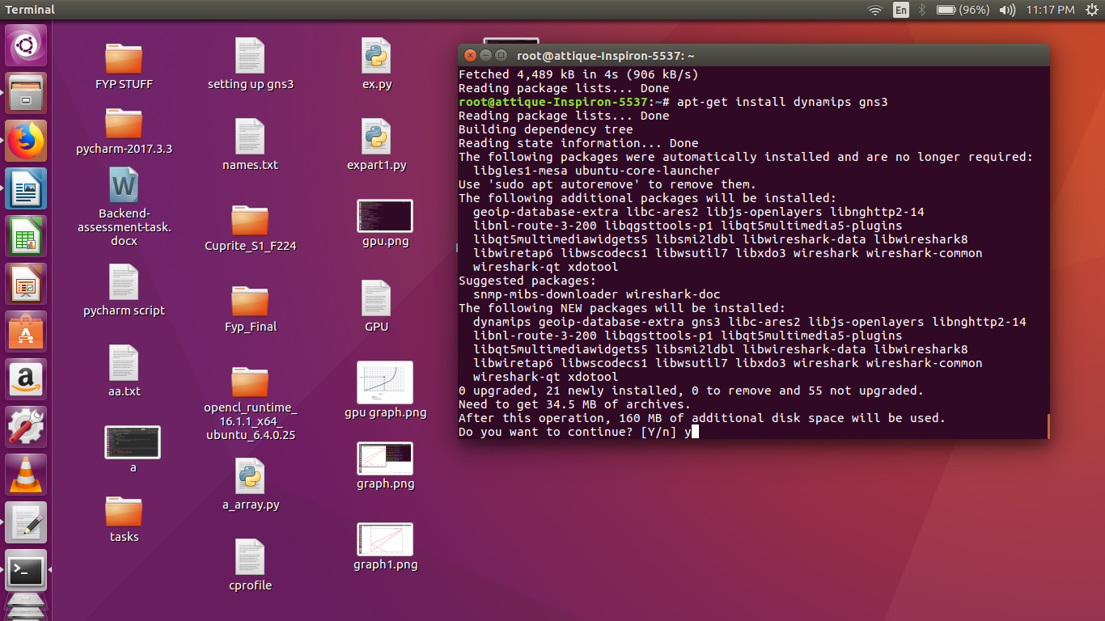

**Install the routers ios images you want to use:**

you can find them and download from:

* <https://www.sysnettechsolutions.com/en/gns3/gns3-supported-ios->images-download/
* I installed c2691 series.

**GNS3 IOUS Support:**

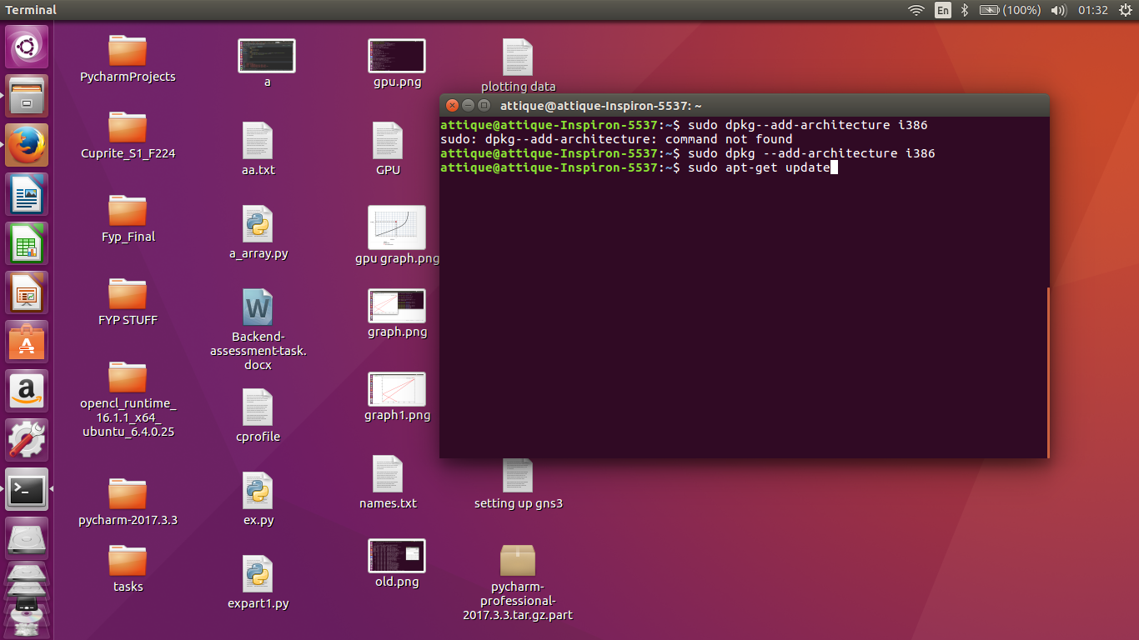

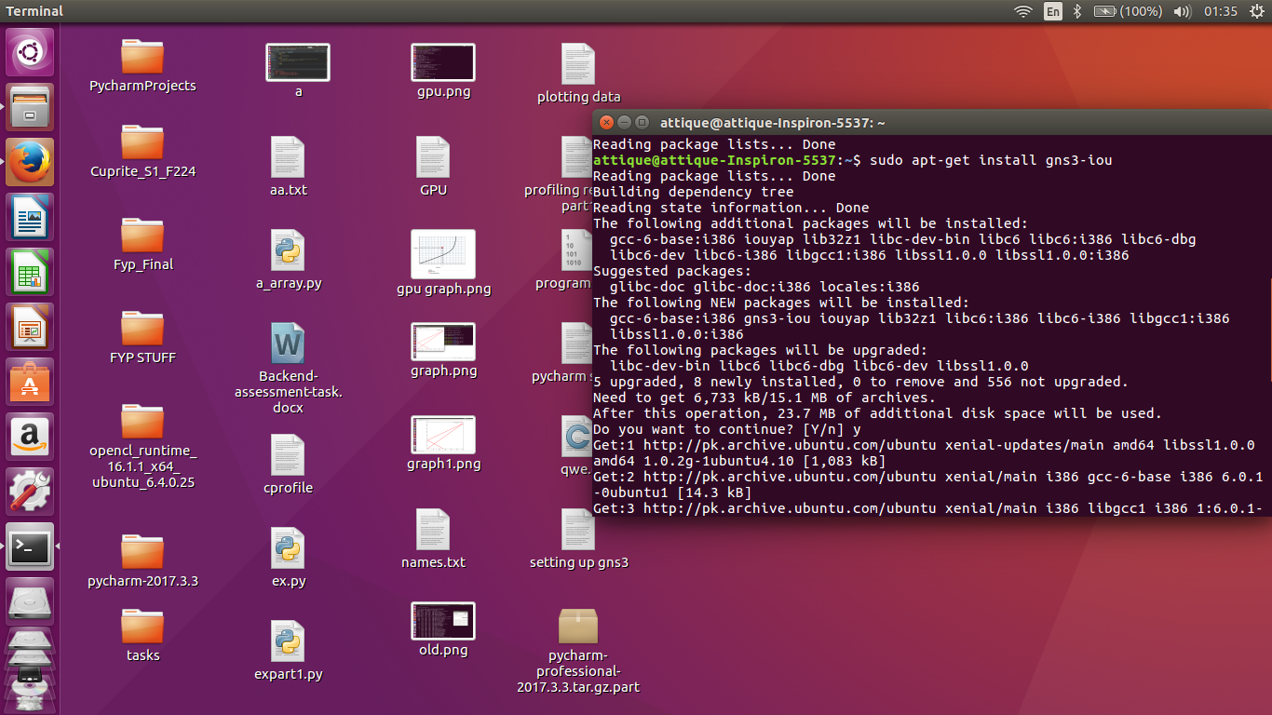

**GNS3 Initial Setup After Installation:**

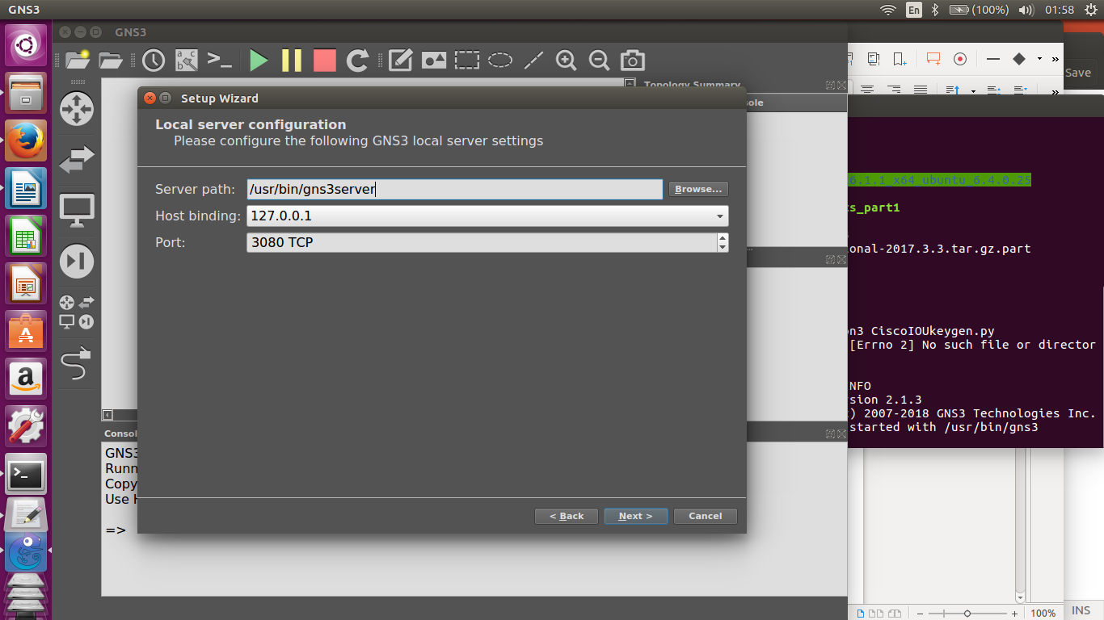

**Two gateway topology:**

* + Place two routers R1 & R2
  + connect them with Ethernet cable with E0/0 at both ends.
  + add loop back addresses on the topology
  + r1 = loopback 0 - 43.1.1.1/8
  + r2 = loopback 0 - 192.168.1.1/24

now hit the run button and when it start hit console. so that all the working routers console is opened.

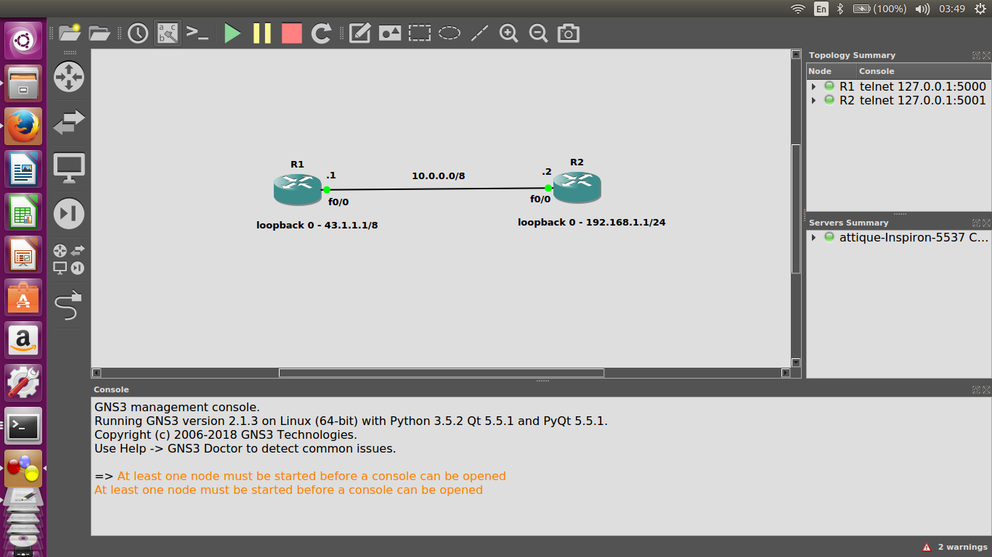

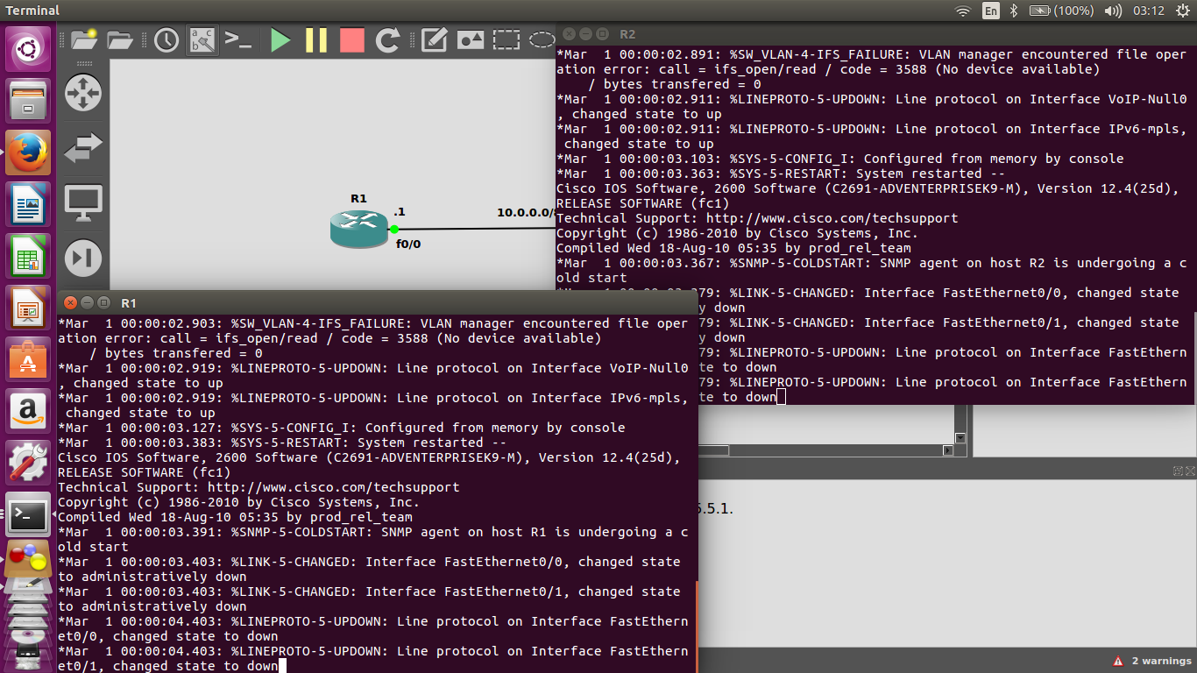

**now go to console of router 1 and type following commands :**

* enable

* conf t

* hostname router1

* no ip domain-lookup

* line con 0

* logging synch

* no exec-timeout

* exit

* int fast 0/0

* ip address 10.0.0.1 255.0.0.0

* no shut

* int loopback0

* ip address

* ip address 43.1.1.1 255.0.0.0

now we are done for R1.

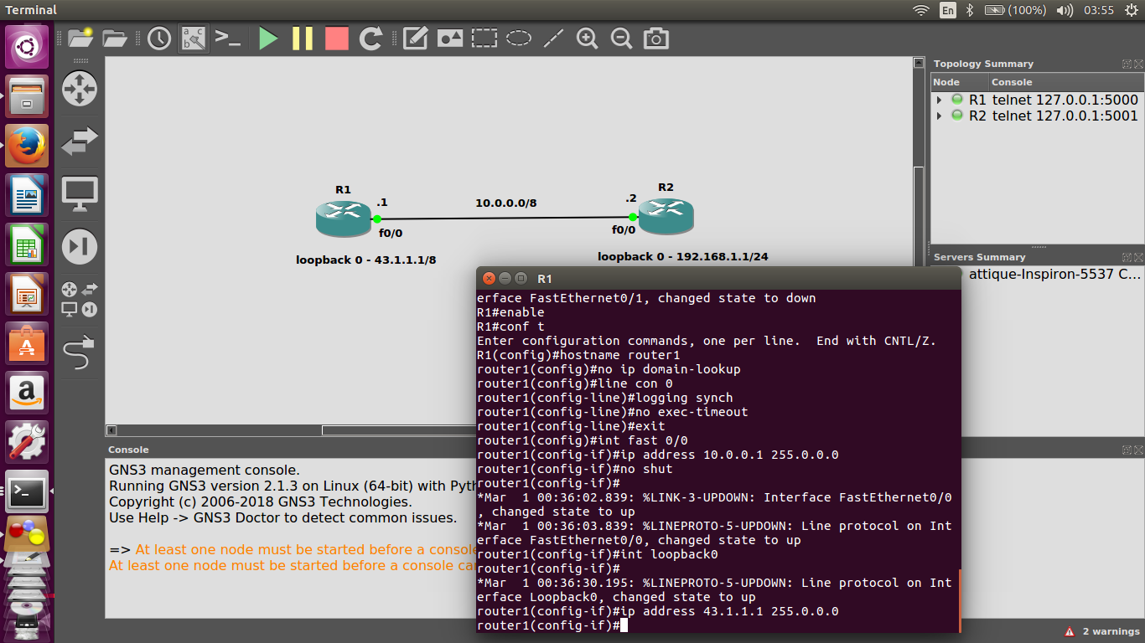

**we need do to do the same for R2:**

* enable

* conf t

* hostname router2

* no ip domain-lookup

* line con 0

* logging synch

* logging synchronous

* no exec-timeout

* exit

* int fast 0/0

* ip address

* ip address 10.0.0.2 255.0.0.0

* no shut

* int fast 0/0

* int loopback0

* ip address 192.168.1.1 255.255.255.0

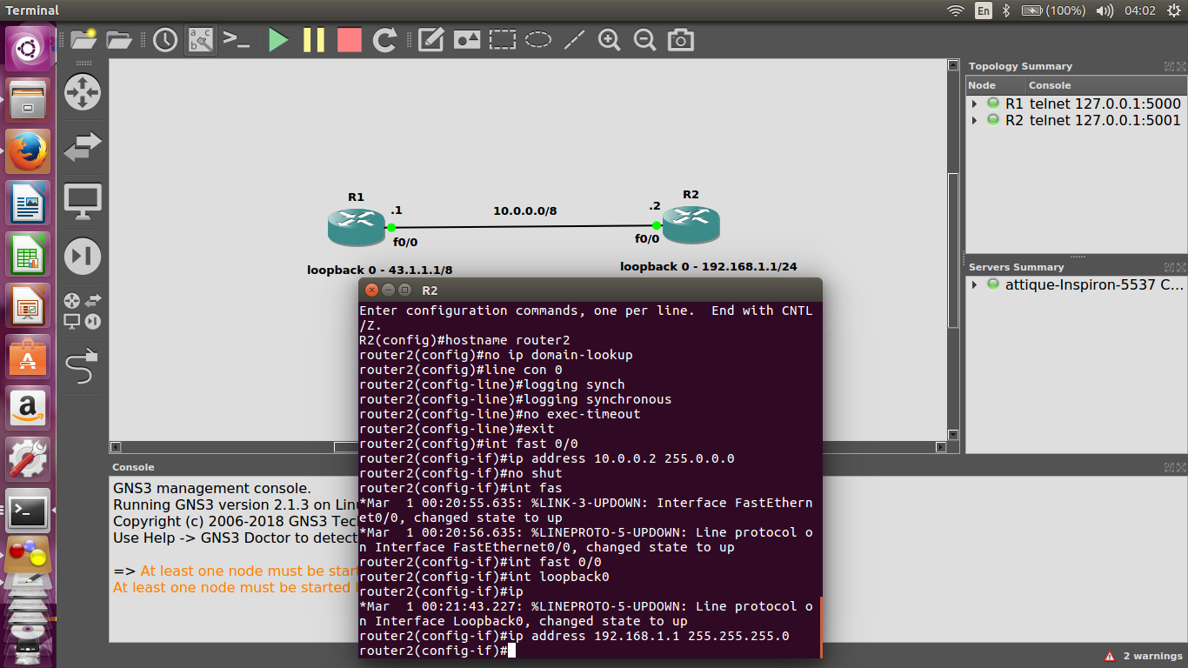

Configs for R1 & R2 are done, now we are going to check router to router connectivity

**to check r1:**

* ping 10.0.0.2

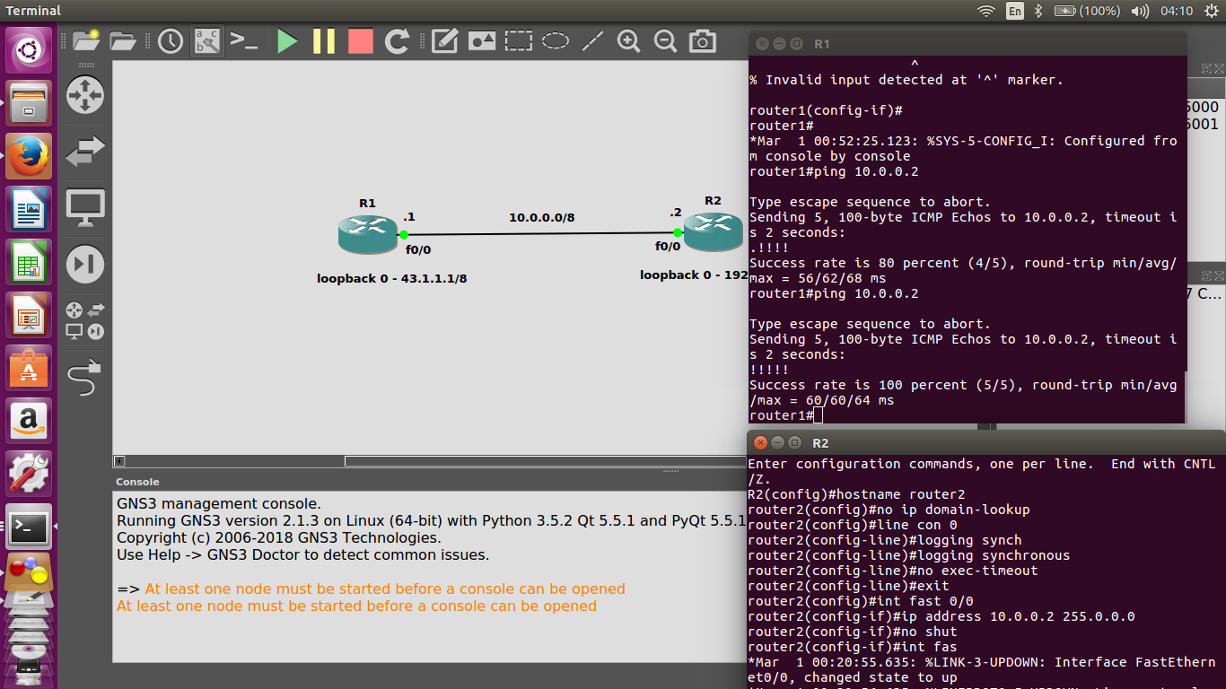

**to check r2:**

* ping 10.0.0.1

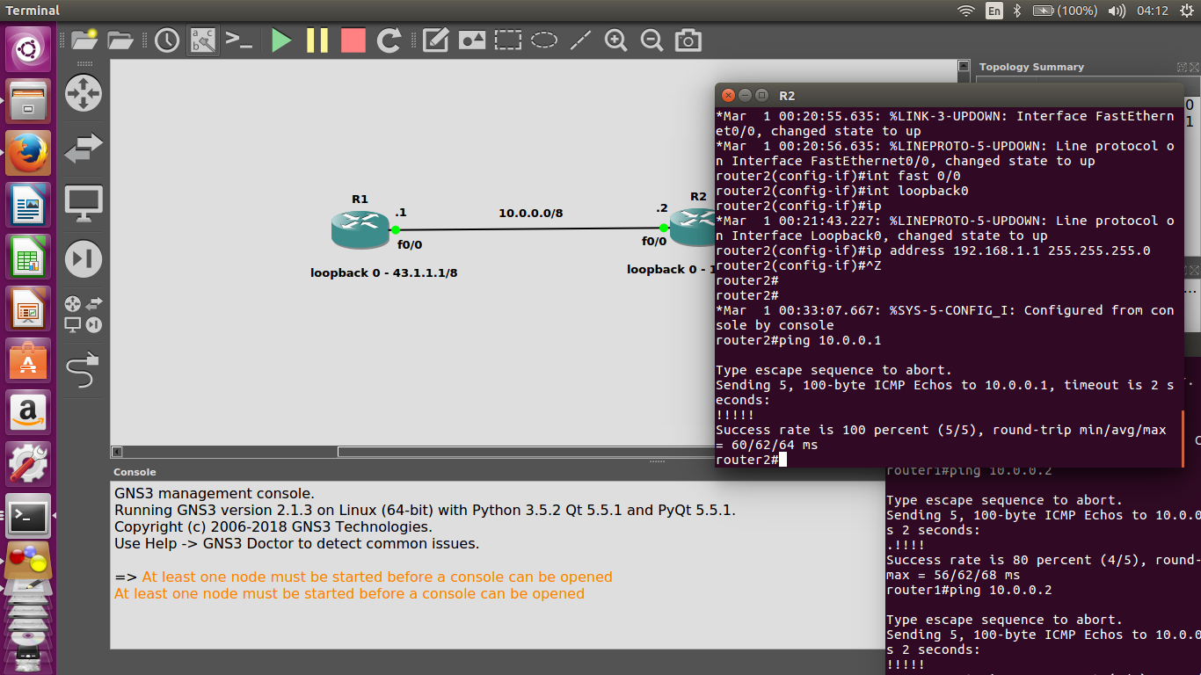

**2. Do/Modify network and change configs in device to enable monitoring and use Solarwinds (included in GNS3) to display vital statistics for a device**

* Download and Install virtualbox
* Once vm is installed and its network preference is set.
* We need to select the path of the ios image of windows that we selected earlier in installation process

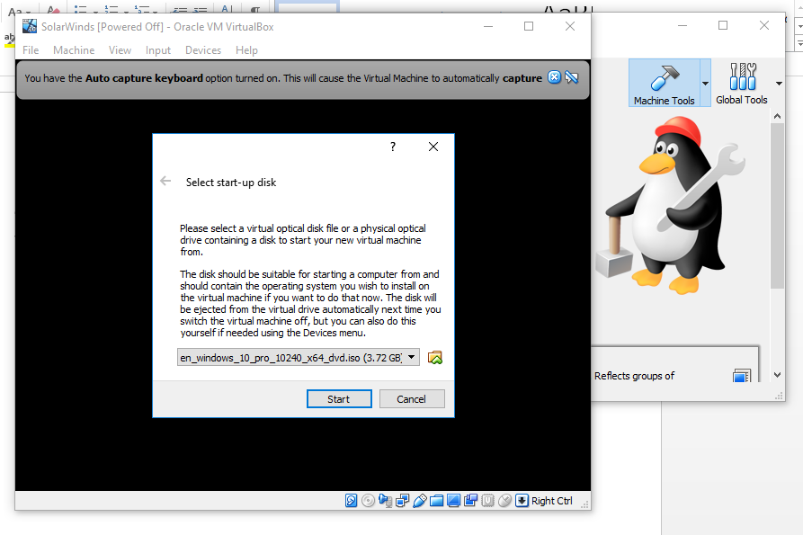

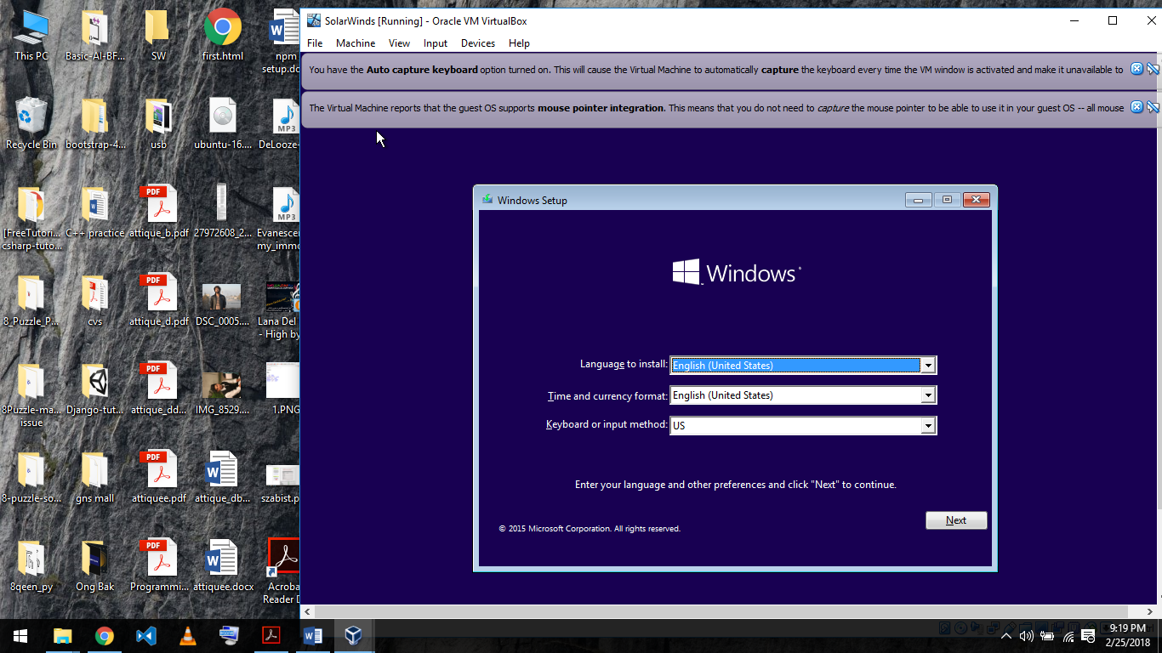**Now install the windows on VM.**

* Now put solarwinds nmp and sqlserver to the shareddrive.
* Then from vm select the option “Install guest CD”
* 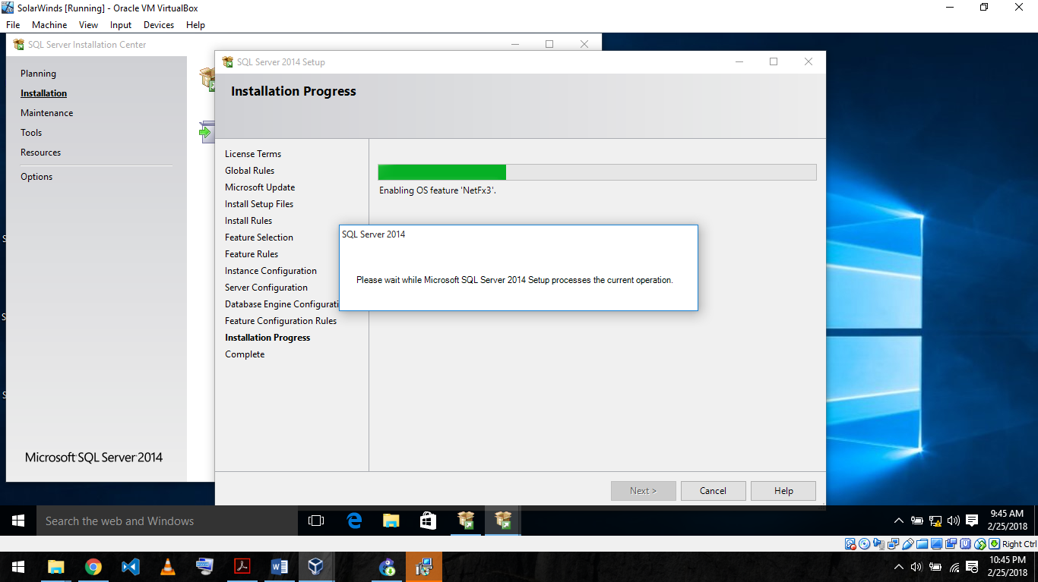Now install sql server in vm
* Install GNS3 on your primary OS.
* Set the ios images in dynamips of the router you wish to install

**Installing SolarWInds :**

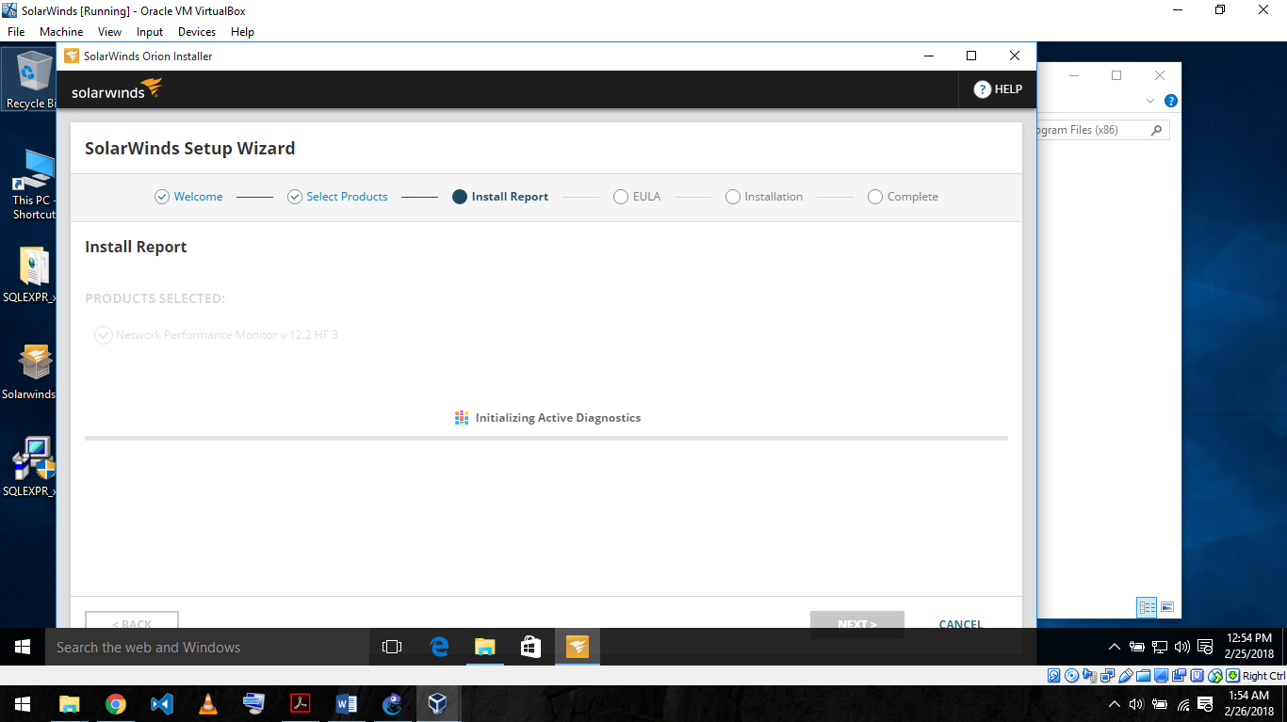

* once installed open solarwinds orion. If it runs fine. Else goto administrative services and start solarwinds orion module engine.

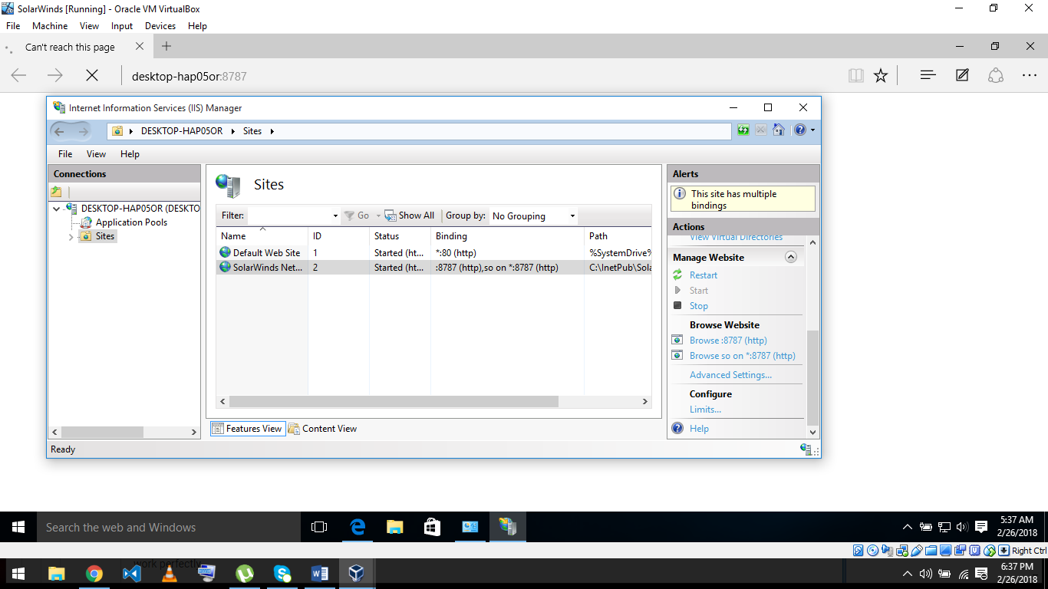**Set the Ip address from Internet Information Services:**

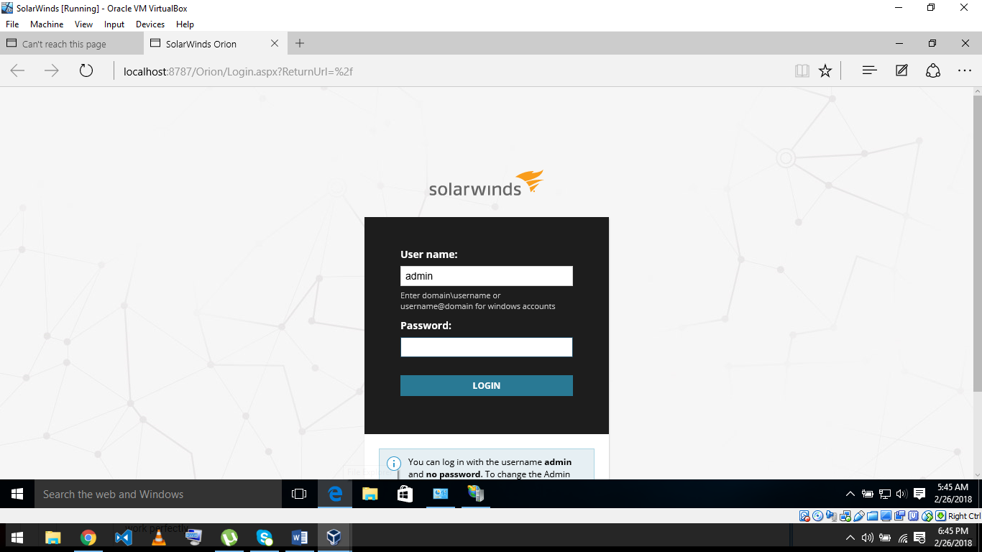**SolarWinds Orion Web Console:**